Grazioso Salvare Rescue Dog Dashboard
Project Overview
This project was developed for Grazioso Salvare to help identify and categorize dogs that are good candidates for search-and-rescue training. The dashboard connects to a MongoDB database containing animal shelter data and allows users to filter and visualize dogs based on specific rescue types.
The application follows an MVC-style structure where:
- MongoDB acts as the data model
- Dash provides the view and controller
- A custom Python CRUD module connects everything together
Required Functionality
The dashboard provides the following functionality:
- Interactive filtering options:
  - Water Rescue
  - Mountain or Wilderness Rescue
  - Disaster or Individual Tracking
  - Reset (returns all data)
- A dynamic data table that updates based on the selected filter
- A geolocation map that displays the selected animal
- A secondary visualization (pie chart) showing breed distribution
- Branding elements including the Grazioso Salvare logo and developer name

Dashboard Screenshots
Default View (Unfiltered)
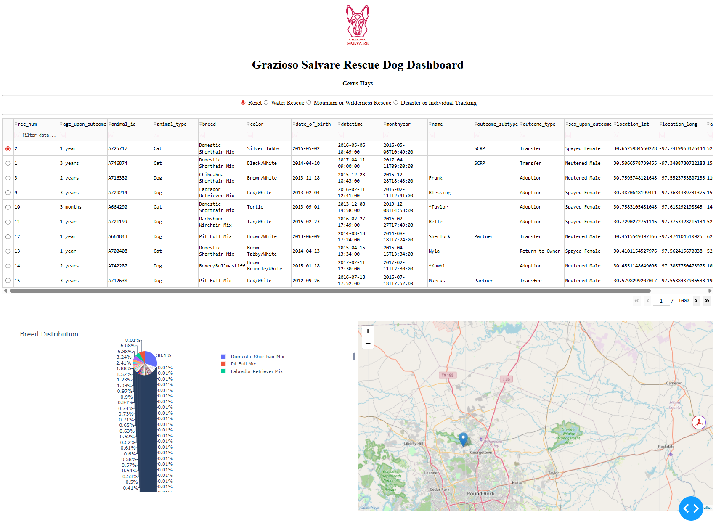

Water Rescue Filter Applied
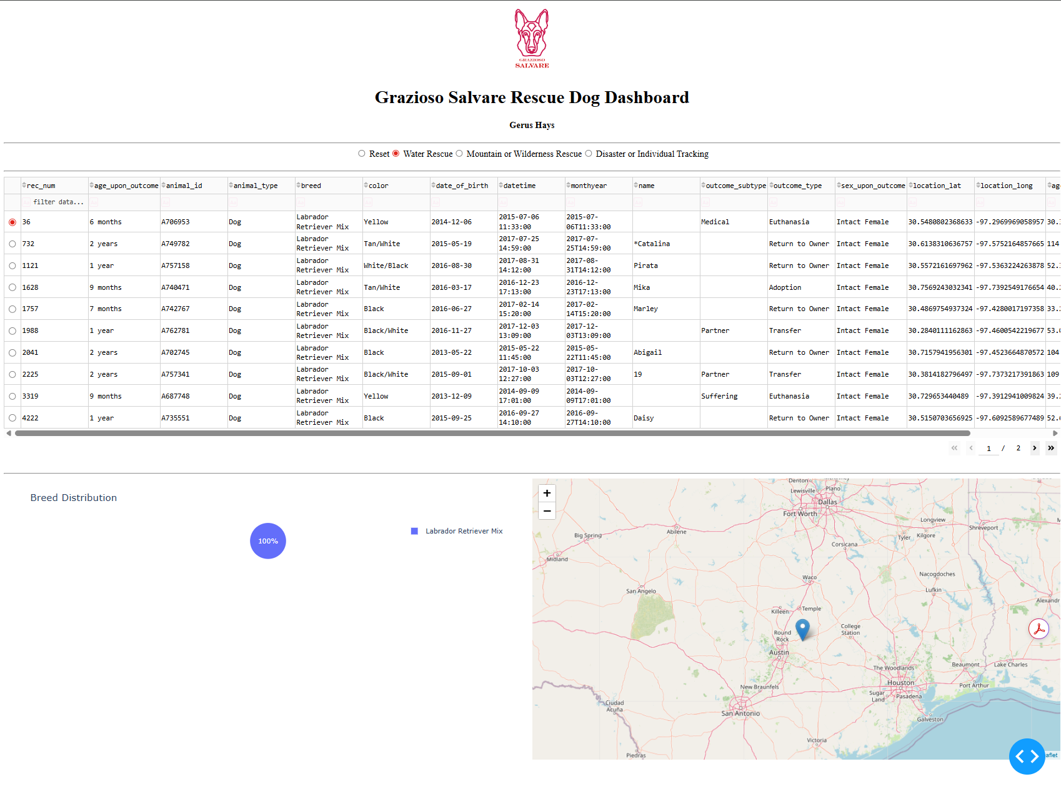

Mountain/Wilderness Rescue Filter Applied
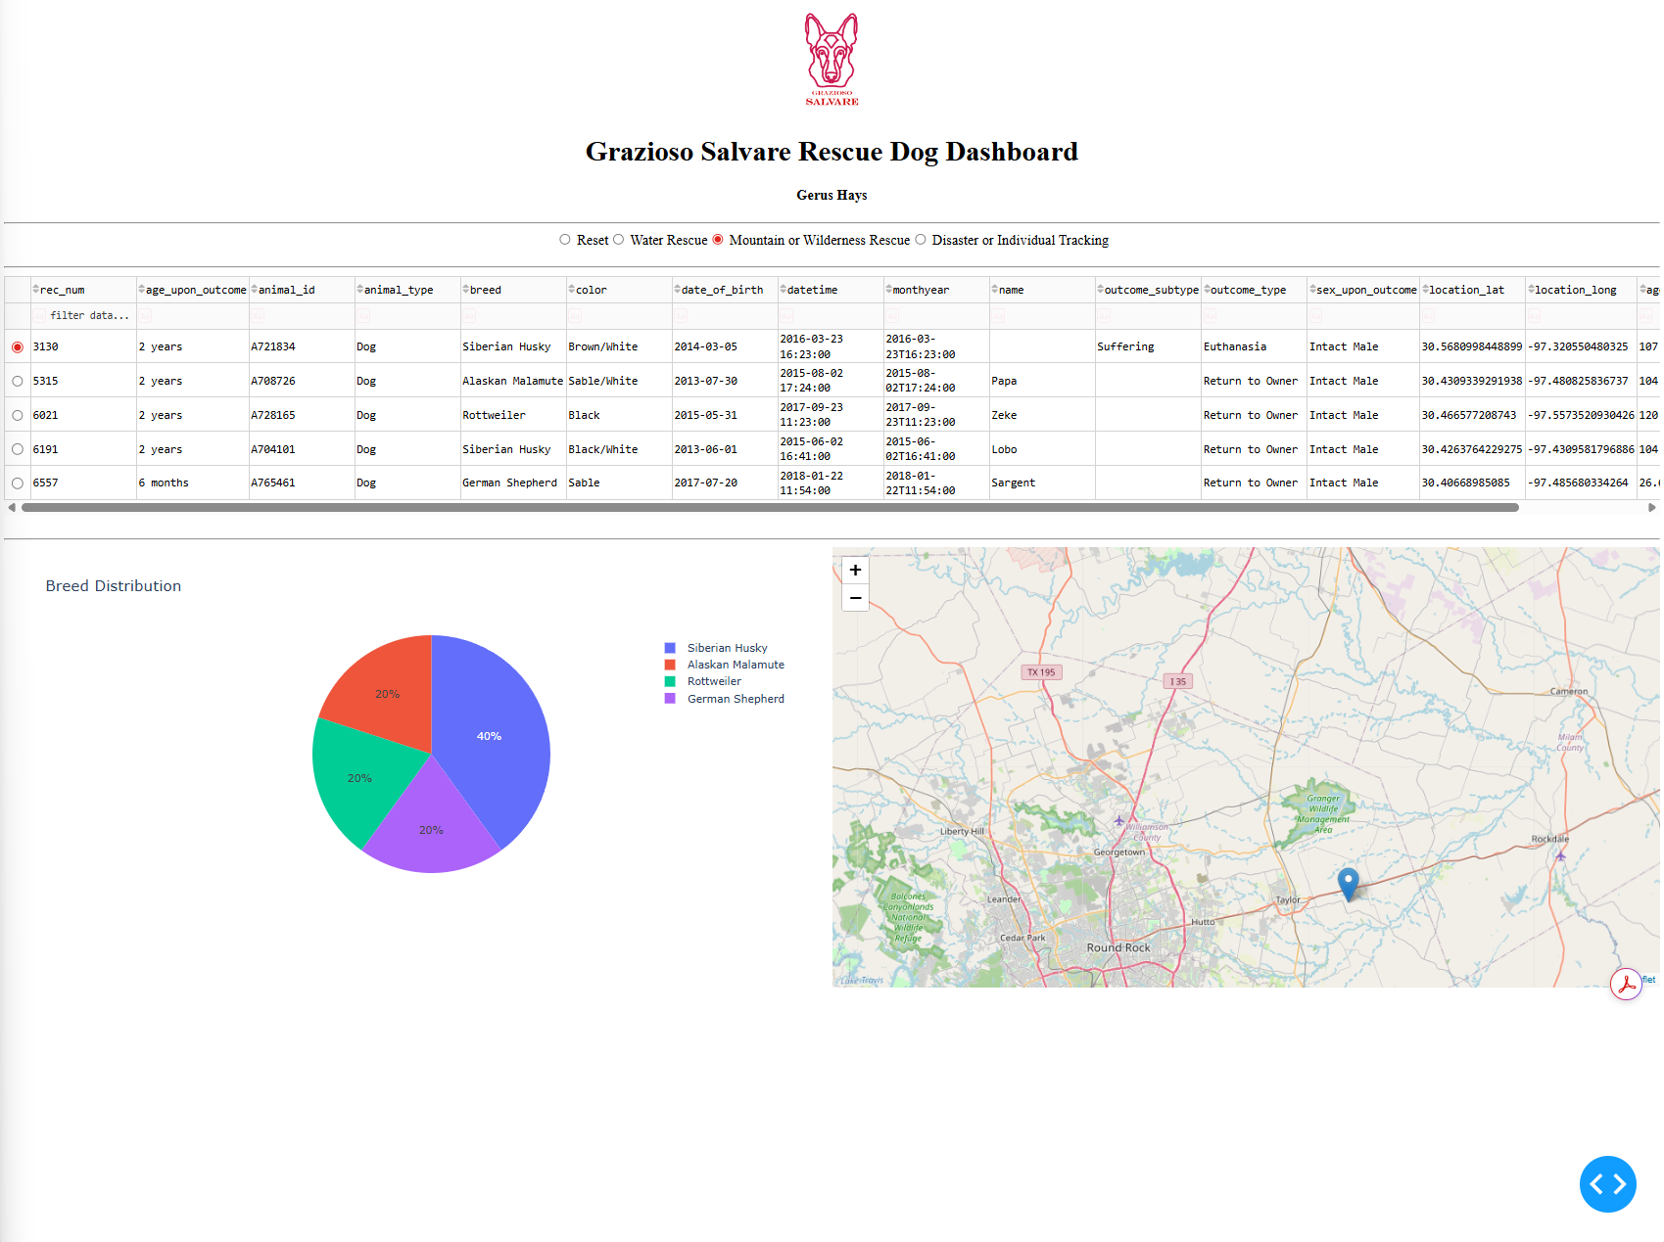

Disaster/Tracking Filter Applied
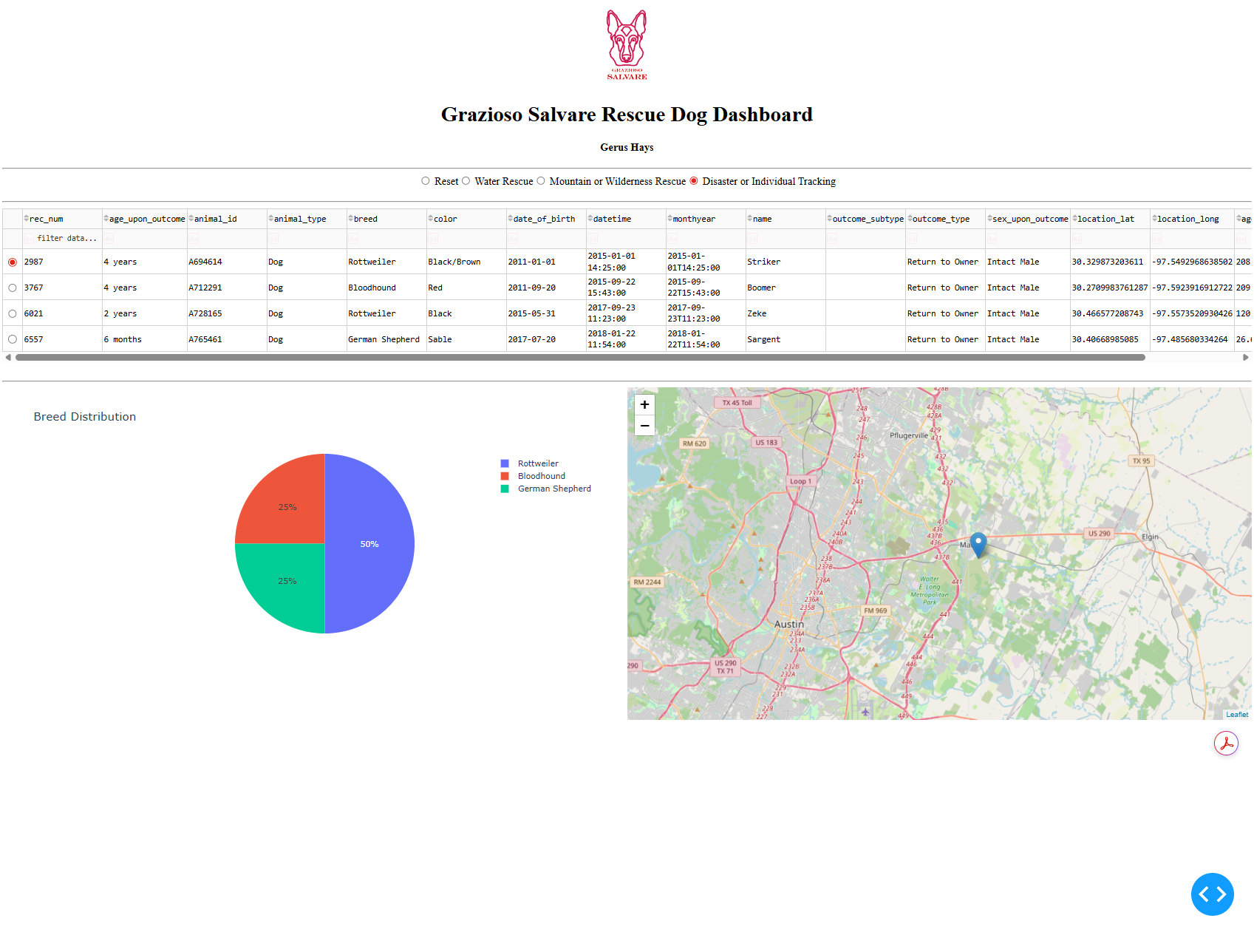

Reset View
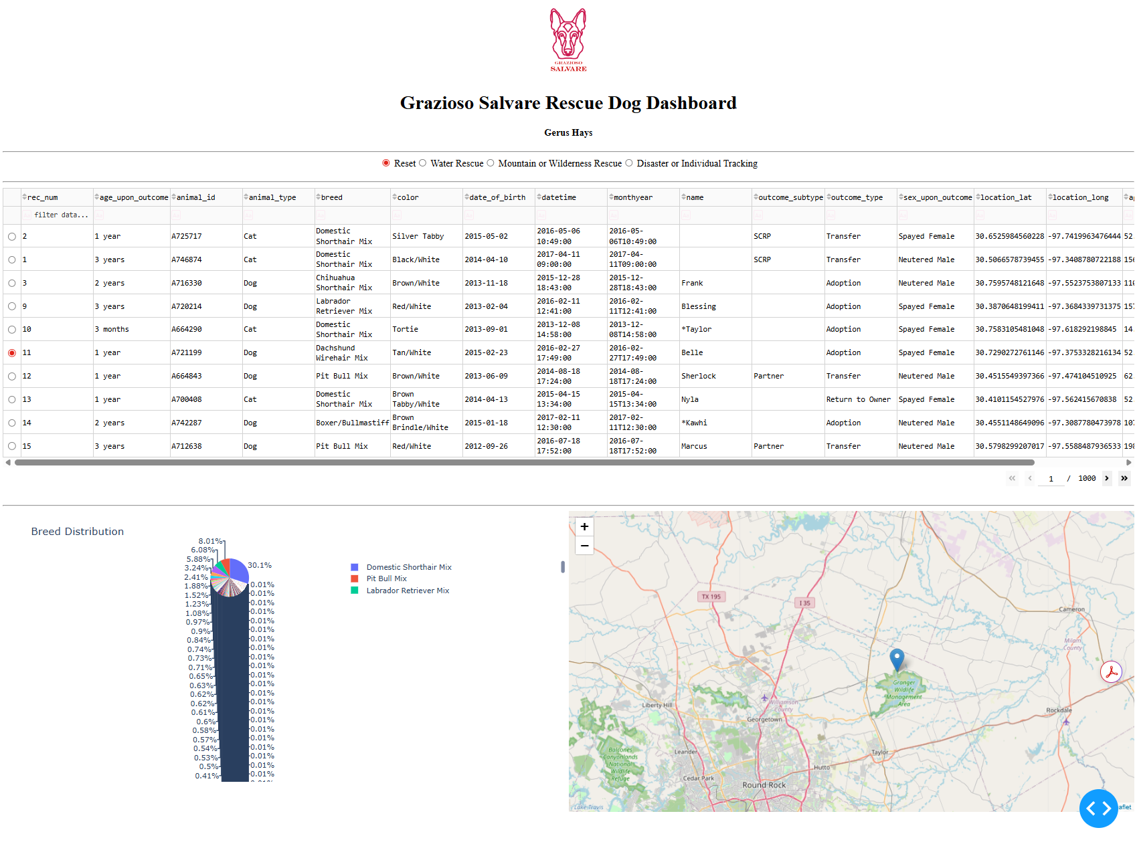Tools and Technologies Used
MongoDB
MongoDB was used as the database because it is flexible and stores data in JSON-like documents, which integrates well with Python. It allows easy querying and filtering without requiring a rigid schema, which is useful when working with real-world datasets like animal shelter records.
Python
Python was used for backend logic and database interaction. A custom CRUD module was developed to handle create, read, update, and delete operations.
Dash Framework
Dash was used to build the web-based dashboard. It allows interactive components like tables, charts, and maps to update dynamically using callbacks. Dash simplifies building data-driven applications without needing traditional frontend development tools.
Additional Libraries
- Pandas: data manipulation
- Plotly Express: charting (pie chart)
- Dash Leaflet: geolocation map
- JupyterDash: running the dashboard inside Codio/Jupyter
Steps Taken to Complete the Project
- Connected to the MongoDB database using the custom CRUD module
- Retrieved all data and displayed it in an initial data table
- Created interactive filter options using Dash radio buttons
- Built MongoDB queries based on rescue type requirements
- Connected filter inputs to the data table using Dash callbacks
- Created a pie chart that updates based on filtered data
- Implemented a geolocation map that displays selected animals
- Added branding elements including logo and name
- Tested all functionality and captured screenshots
Challenges and Solutions
One challenge was ensuring that the filter queries returned the correct results due to variations in breed naming within the dataset. This was addressed by adjusting queries and verifying data structure using test queries.
Another issue was handling dashboard display errors, such as null values being passed into callbacks. This was resolved by adding conditional checks to prevent runtime errors.
Additionally, resizing the dashboard for proper screenshots required switching from inline mode to external mode, allowing full-page rendering.

